**Step:1**

Look for **810 [S01] Mone-G SOLMAN** connection on SAP Logon pad. Double click on it and proceed to **Step:3**

If you do not find this option, please go to **step:2** and add the connection.

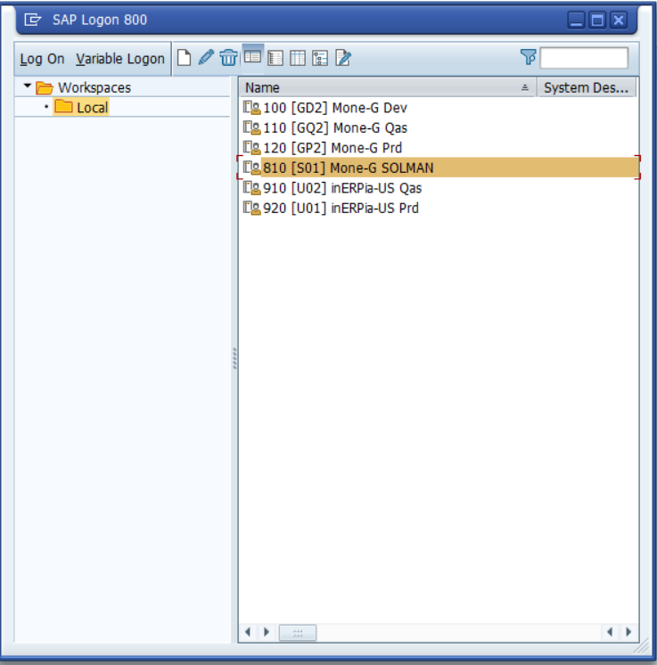

**Step:2**

Please update your logon pad with below app server details as shown below

**New** > **Connection > Custom Application Server**

**App Server**: 10.210.6.50 **Instance**: 00 and **System ID**: S01

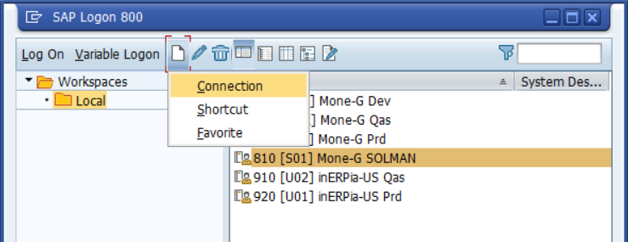

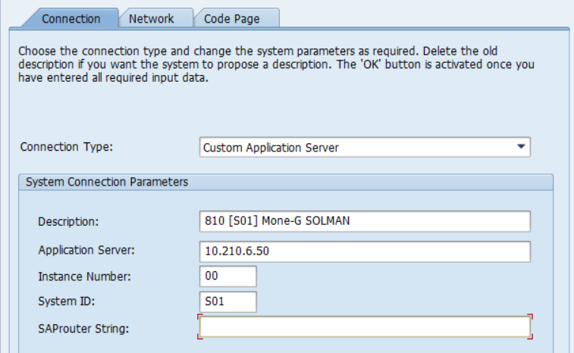

Click **Next** > **Next** > **Finish**.

Now you will see the Solman connection available on your logon pad.

**Step:3**

By default, client will be setup as 100 which is correct.

Input your **SAP user Id** and Initial password as: **Password123456&**

It will prompt to setup a productive password.

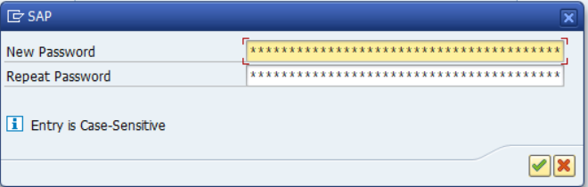

**Step:4**

Basis team is yet to configure the SSO for CHARM. For time being, please use below URL to access CHARM:

<https://vhmcys01ci.pce.sharedom.net:50001/sap(bD1lbiZjPTEwMCZkPW1pbg==)/bc/bsp/sap/crm_ui_start/default.htm?sap-client=100&sap-language=EN>